1. Display the Supplier name and the Quantity sold.

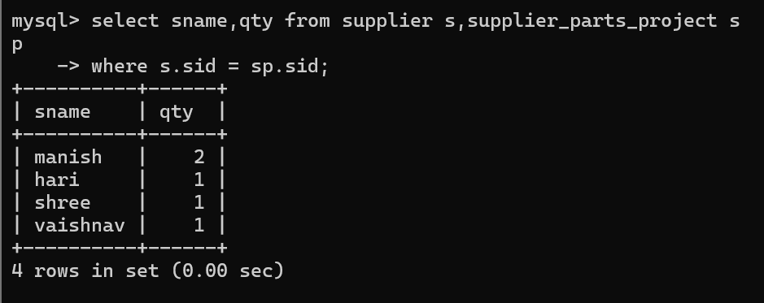

2. Display the Part name and Quantity sold.

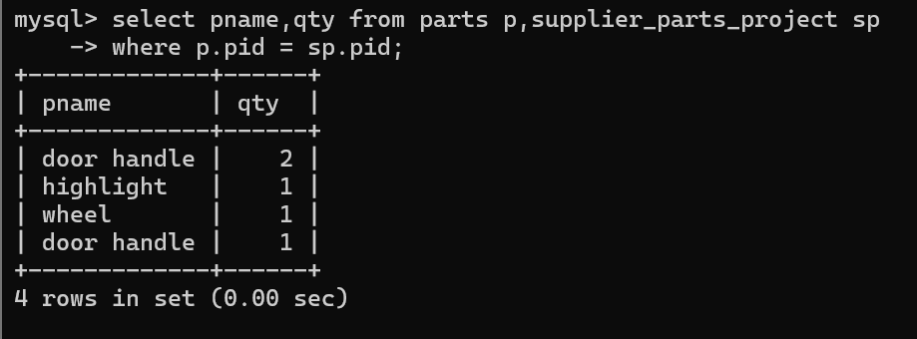

3. Display the Project name and Quantity sold.

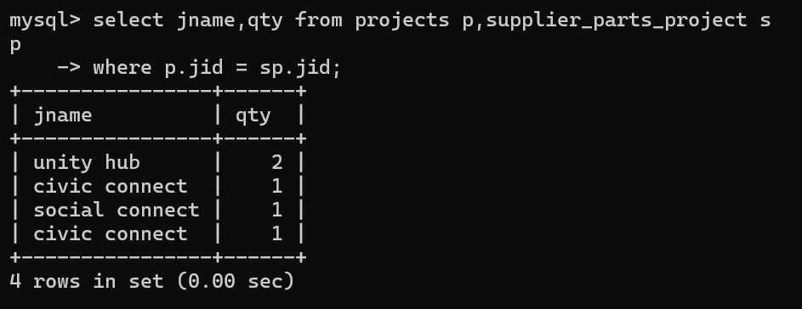

4. Display the Supplier name, Part name, Project name and Quantity sold.

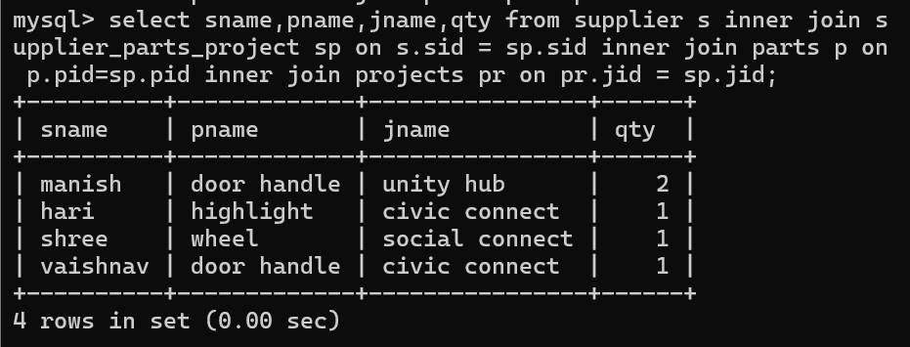

5. Display the Supplier name, Supplying Parts to a Project in the same City.

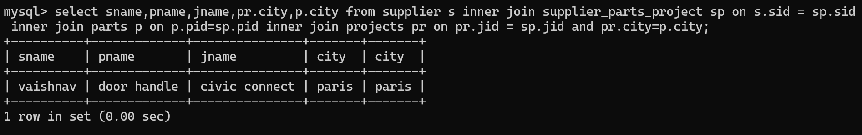

6. Display the Part name that is ‘Red’ is color, and the Quantity sold.

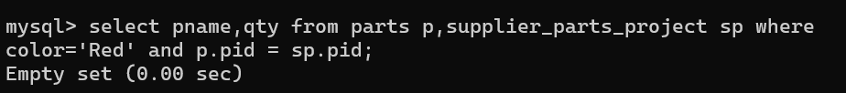

7. Display all the Quantity sold by Suppliers with the Status = 20.

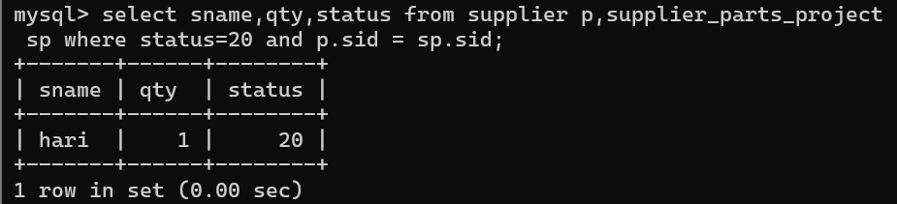

8. Display all the Parts and Quantity with a Weight > 14.

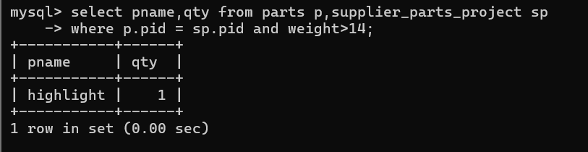

9. Display all the Project names and City, which has bought more than 500 Parts.

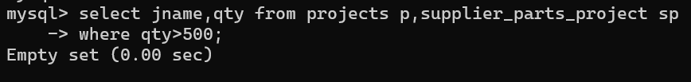

10. Display all the Part names and Quantity sold that have a Weight less than 15.

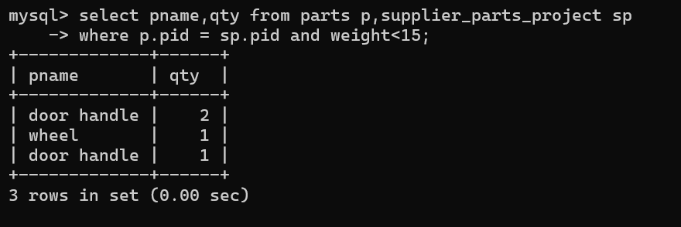

11. Display all the Employee names and the name of their Managers.

